**AtCMU UI Design description**

**(Latest modified: 12.02.2014)**

**Function descriptions**

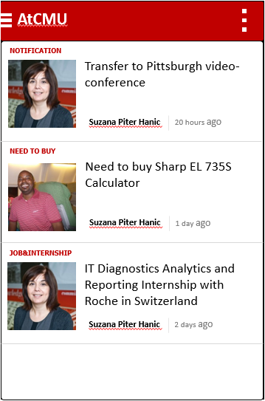

**3.**

**2.**

**1.**

1. **Menu**

Open main menu by dragging left to right or clicking menu icon.

1. **Feeds Filter**

User can select feeds in different classes.

1. **Feeds Item**

Containing basic information about feeds including topic, name & photo of the sender, brief description, time of posting. User can see the detail information by clicking the feeds items.

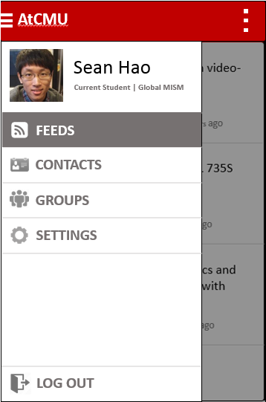

**9.**

**8.**

**7.**

**6.**

**5.**

**4.**

1. **Profile**

Containing basic information of the user.

1. **Feeds**

Containing feeds that tagged by “Favorite feeds”.

There will be a function to add a feed to Favorite for later reading.

1. **Contacts**

Click will show the contact list, details of contact list will explain in the next interface.

1. **Group**

Showing information by groups. Need further design.

1. **Settings**

Including user’s preferences on receiving push notification and so on.

1. **Log out**

Delete user’s token and return to login page.

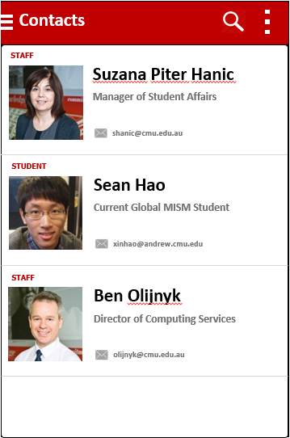

**?**

**12.**

**11.**

**10.**

1. **Search button**

To search the contacts by name. (maybe could search by other terms in later release)

1. **Contacts filter**

Filter the contact list by category like “Current Students”, “Faculty” and “Alumni”.

1. **Contacts Item**

General information of the person will be shown in this page like avatar, position, program and email etc. Click the item will show a detailed profile page about the person including location, interests, phone, email etc.

?. Export multiple contacts to mobile phone contact list. This function should be a very useful one but we haven’t thought of a good way to perform the interaction.

**Summary**

AtCMU app is designed to be a mobile news reader, providing students, faculty and alumni with convenience to read notice, updates, buying and selling information anywhere and anytime. The more people read, the more people will post, which is absolutely a good thing for the website.

Apart from that, AtCMU app could bring new value to AtCMU website when combining the information from website and the mobile features of app. For example, the app could easily get the contacts information from the website. In this way, users could easily look up the information of someone they like to know in the campus and get in touch with each other instantly.

The UI will be consistent with CMU websites, which is a combination of red, gray and white.